**1.POST (Register new User)**

**Path:** <http://localhost:5100/auth/register>

**Screenshot:**

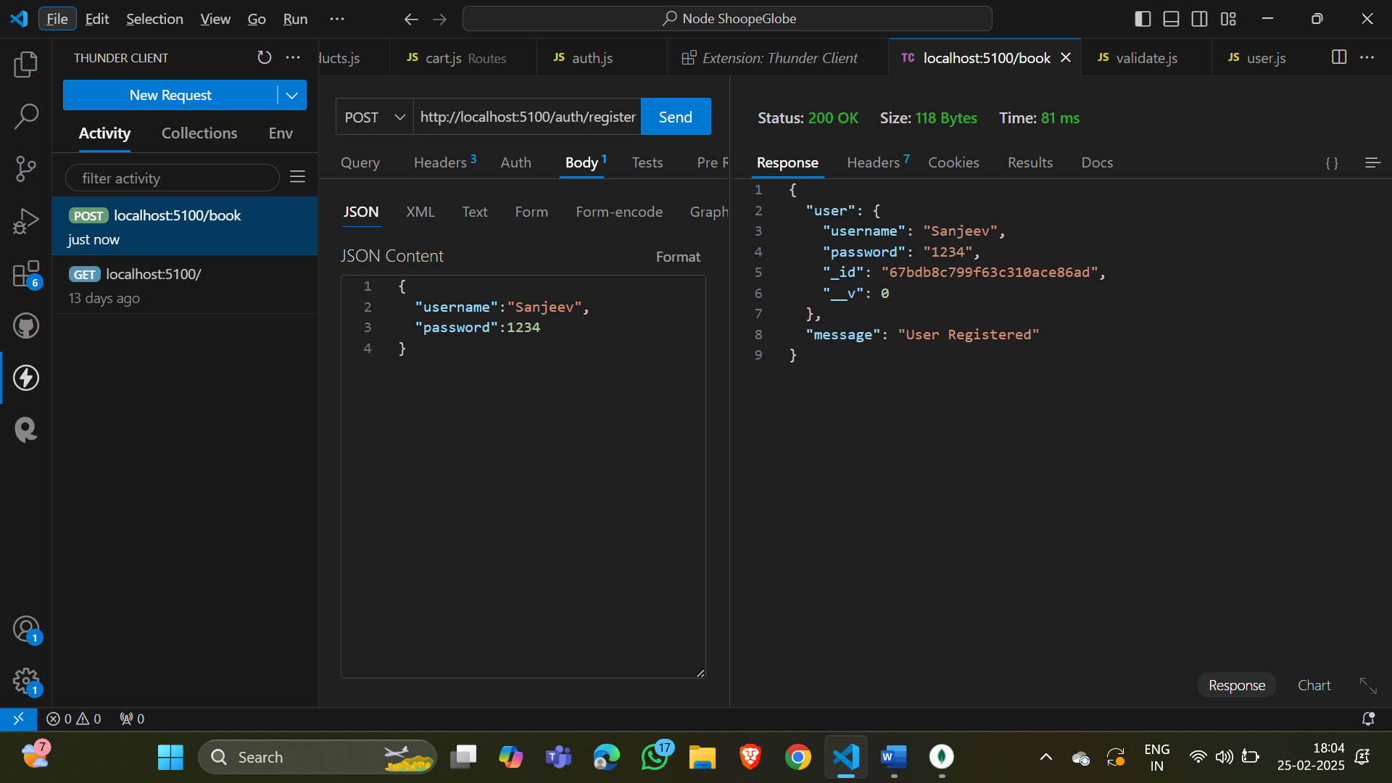

Database

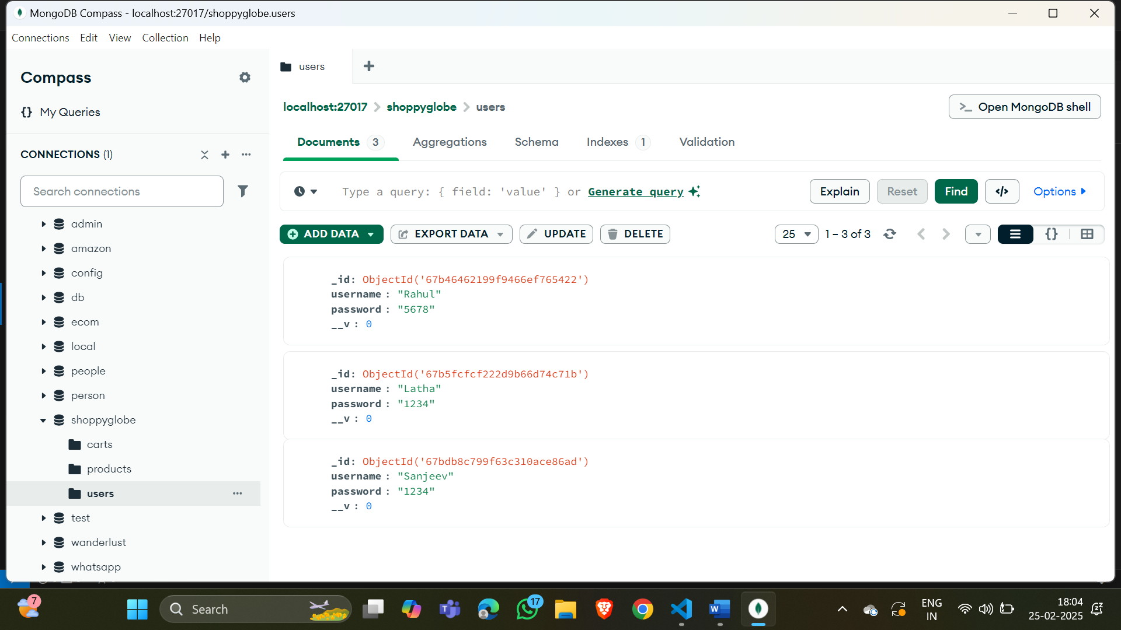

**Result: Added new user(Sanjeev with password 1234) successfully.**

**2.POST (Login User)**

**Path:** [**http://localhost:5100/auth/login**](http://localhost:5100/auth/login)

**Screenshot:**

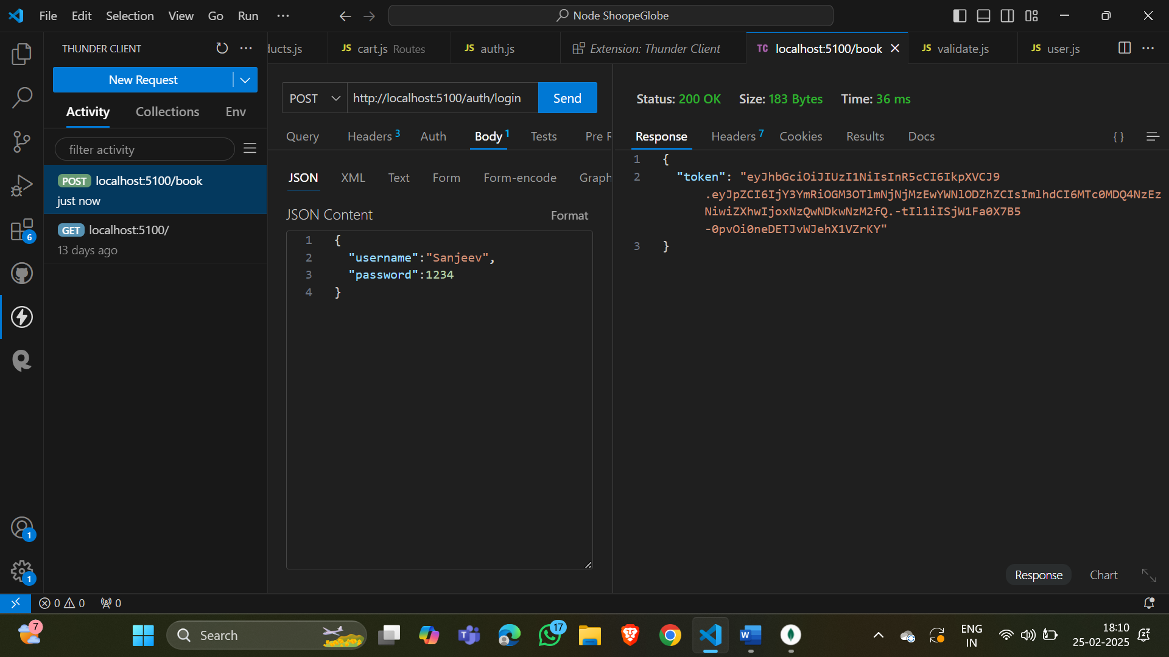

**Database:**

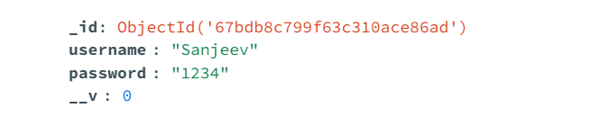

**Result: Login (Sanjeev with password 1234) successfully.**

**3.GET (All products)**

**Path:** [**http://localhost:5100/products/**](http://localhost:5100/products/)

**Screenshot:** 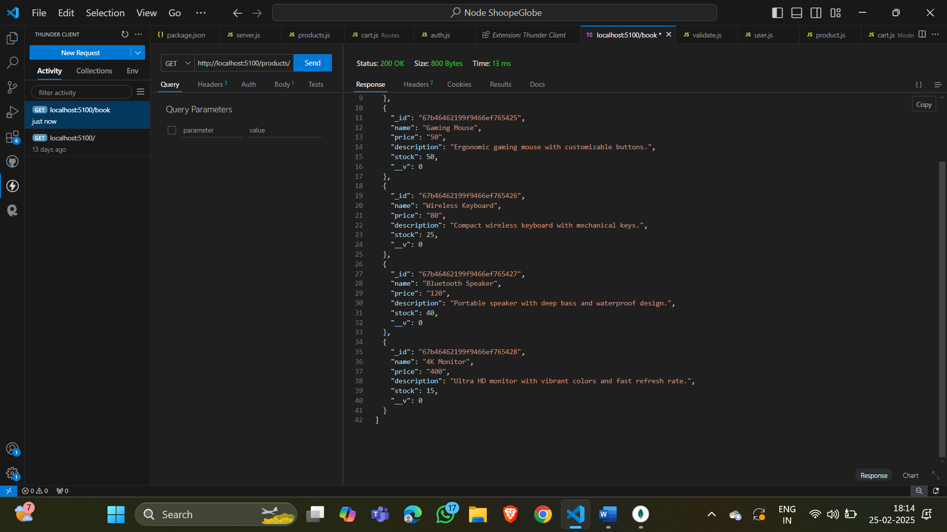

**Database:**

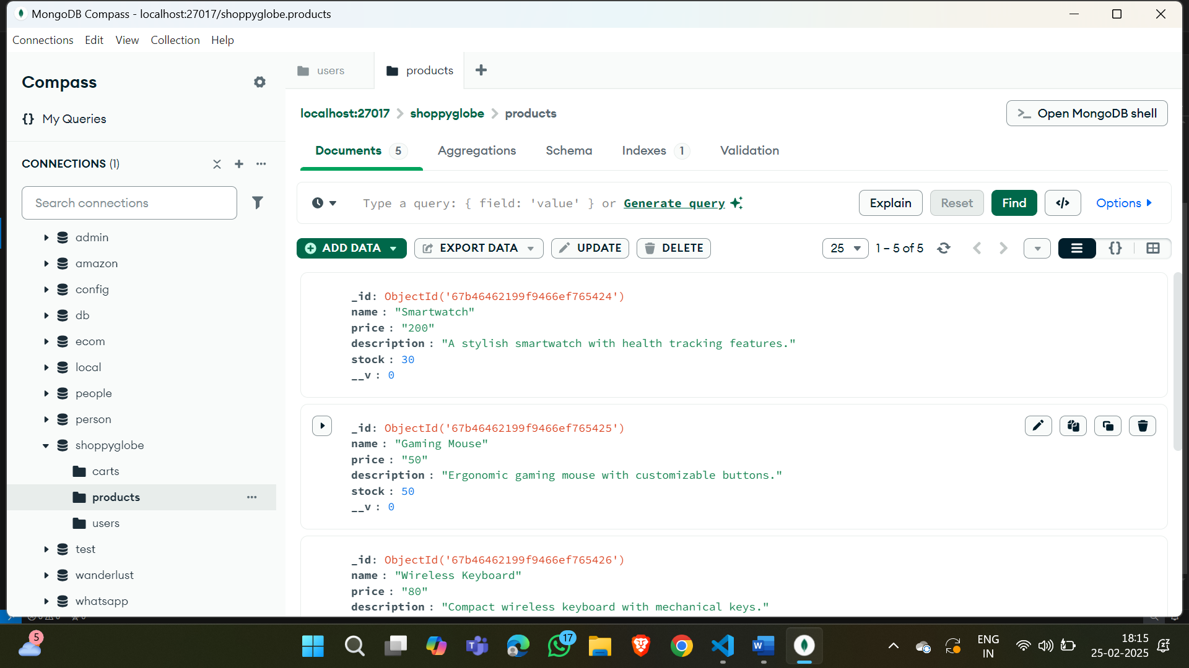

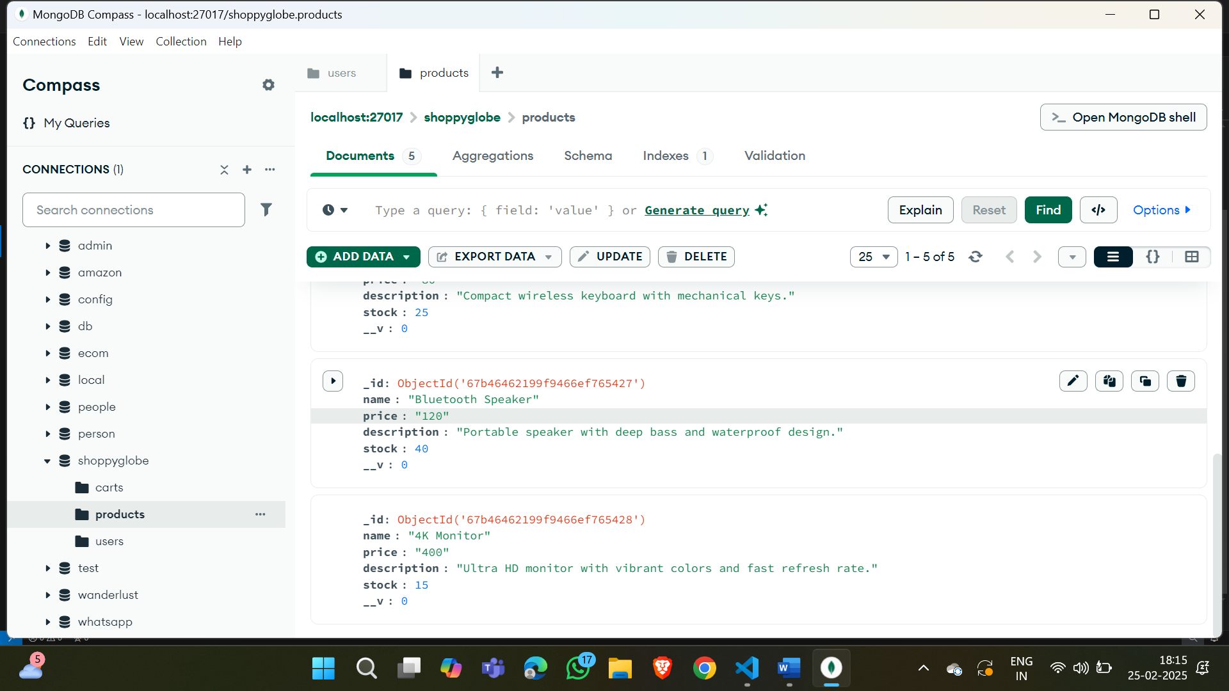

**Result:Fetched all products successfully.**

**4.GET (Specific Product)**

**Path:**  [**http://localhost:5100/products/67b46462199f9466ef765425**](%20http:/localhost:5100/products/67b46462199f9466ef765425)

**Screenshot:**

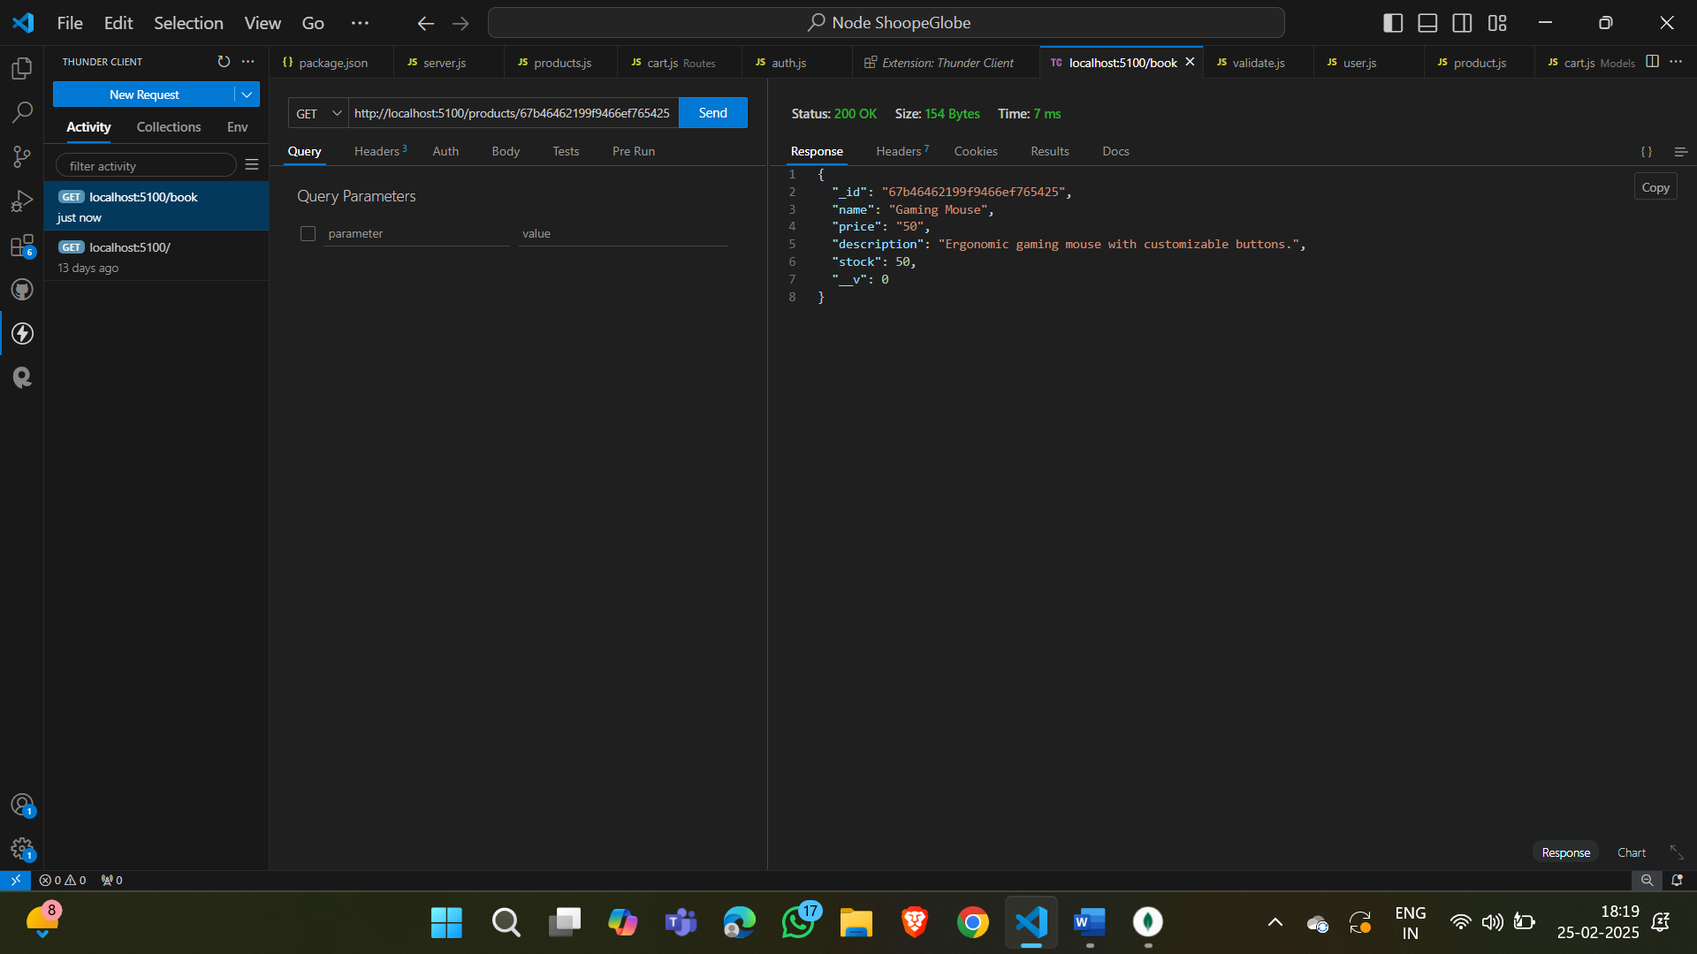

**Database:**

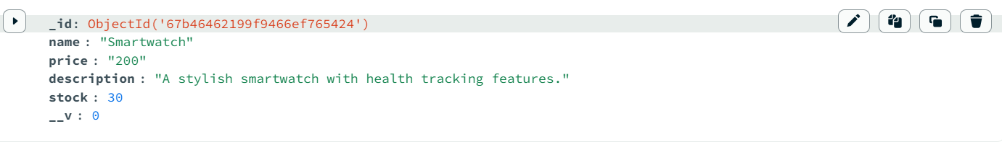

**Result: Fetched details of specific product successfully.**

**5.POST (Add new product to cart)**

**Path:** [**http://localhost:5100/cart/**](http://localhost:5100/cart/)

**Screenshot:**

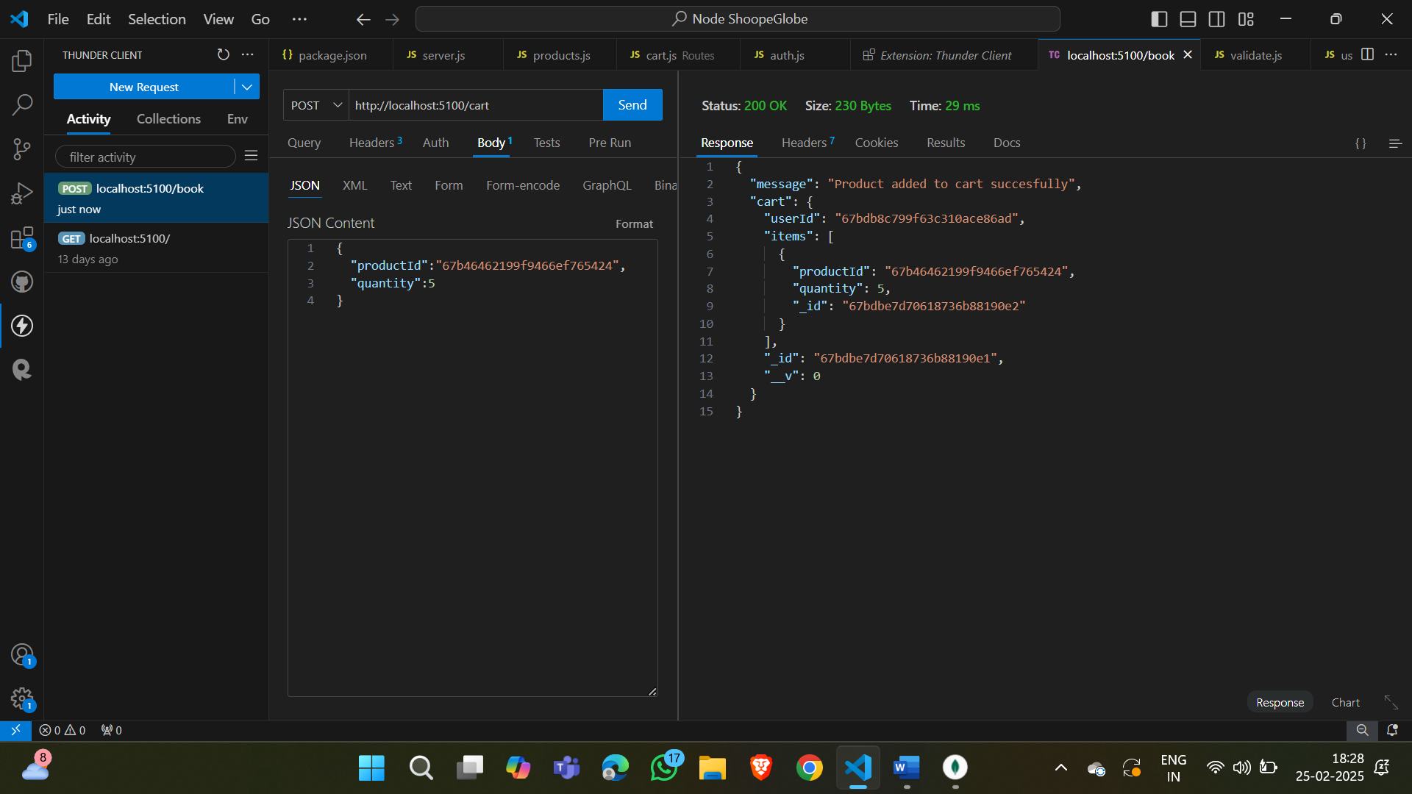

**Database:**

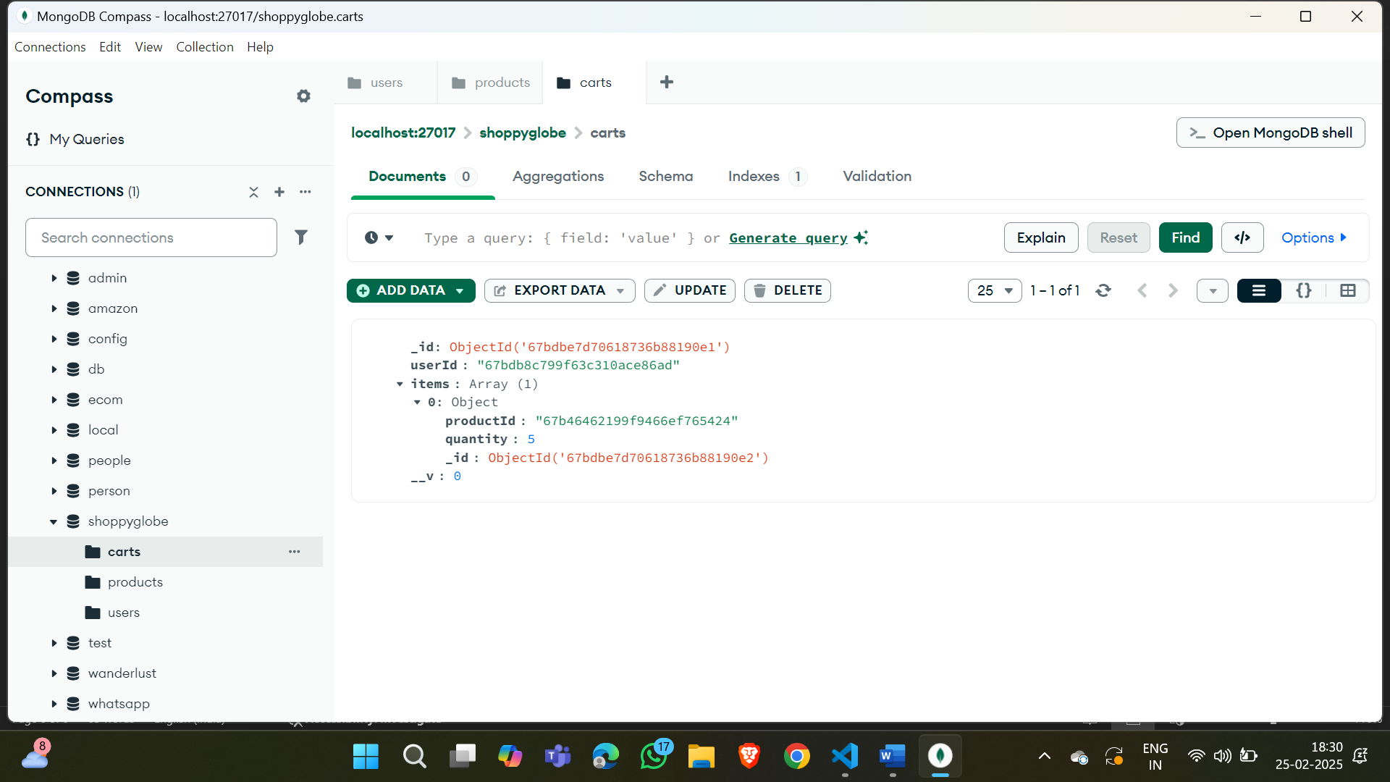

**Result:Added a product(with quantity 5) into user cart after authorization(JWT Token) successfully.**

**6.PUT (Modify existing product quantity in cart)**

**Path:** [**http://localhost:5100/cart/**](http://localhost:5100/cart/)

**Screenshot:**

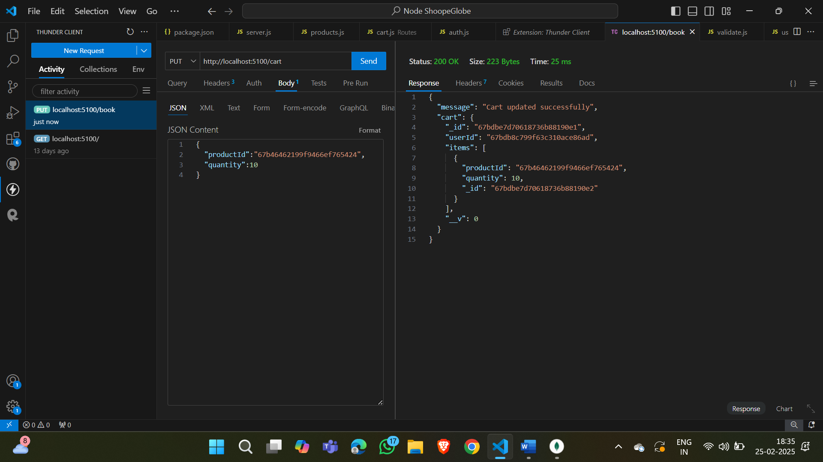

**Database:**

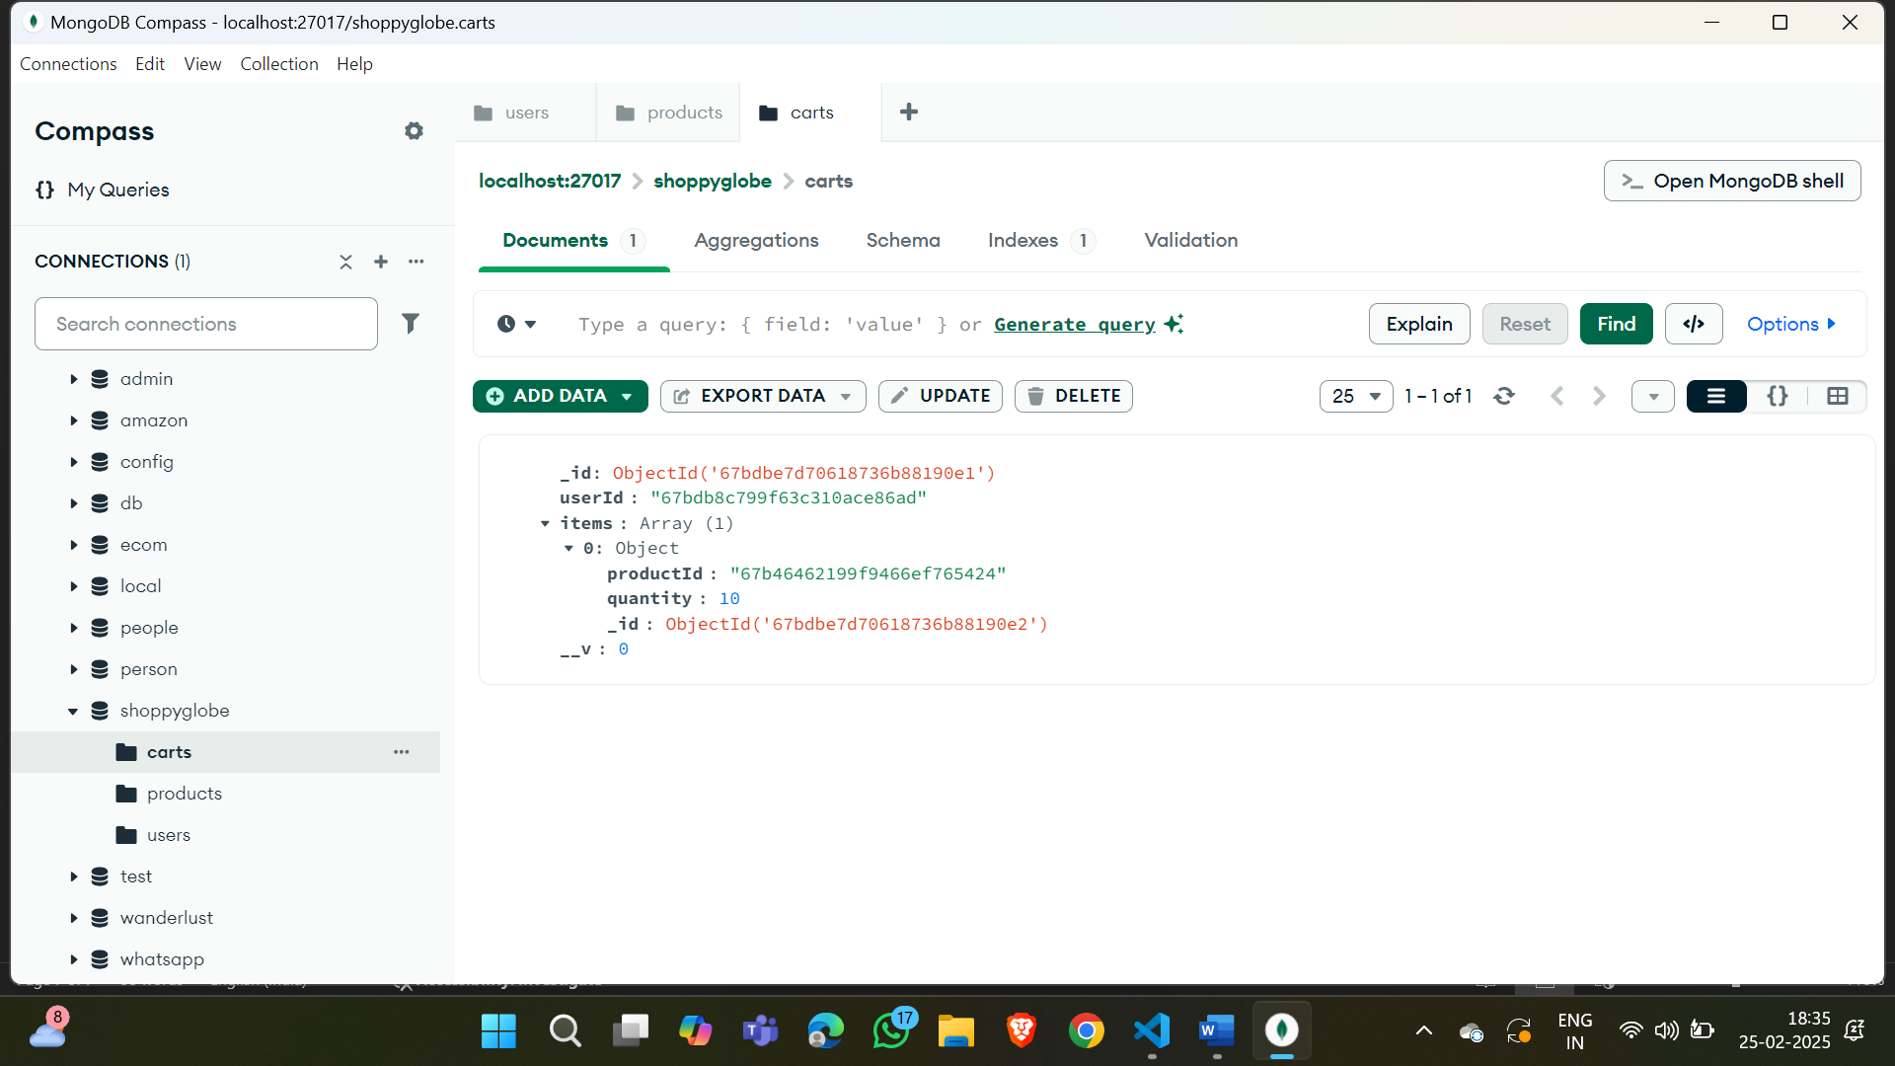

**Result:Modified prodcut quantity(5🡪10) successfully.**

**7.DELETE(Remove a product from cart)**

**Path:** [**http://localhost:5100/cart/**](http://localhost:5100/cart/)

**Screenshot:**

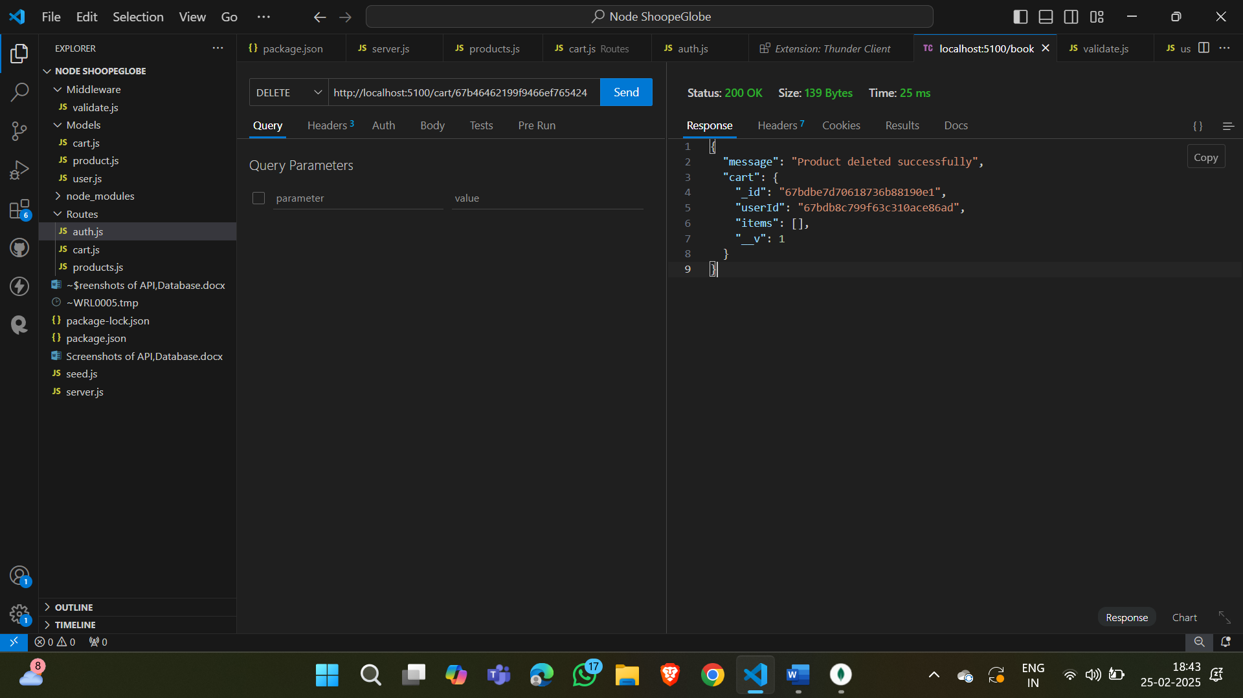

**Database:**

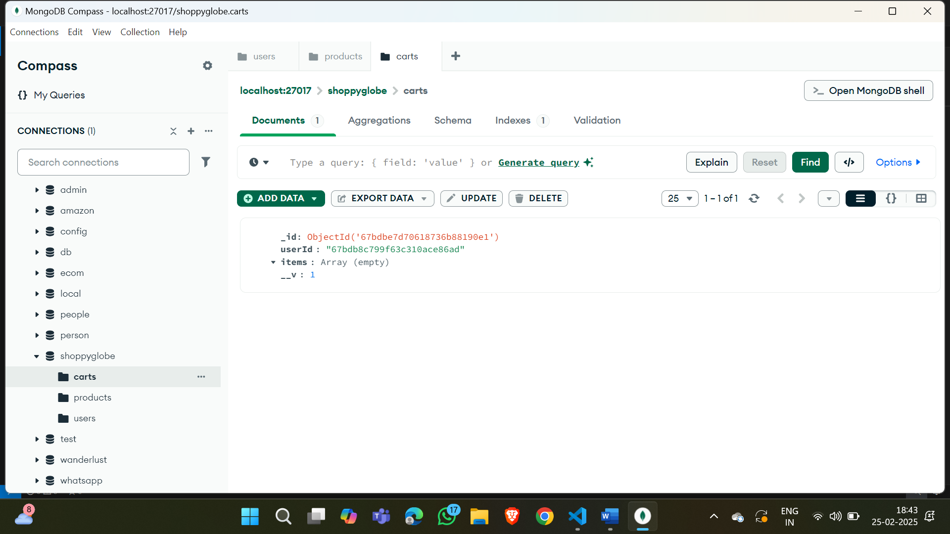

**Result: Product in the cart deleted (items) succesfully.**